Stage 2 – "Your move creep"
COURSE DESIGNER: Ryan Christenson
SCORING: Comstock 33 rounds.
TARGETS: 11 cardboard targets.
SCORED HITS: 3 Best hits per carboard will be scored.

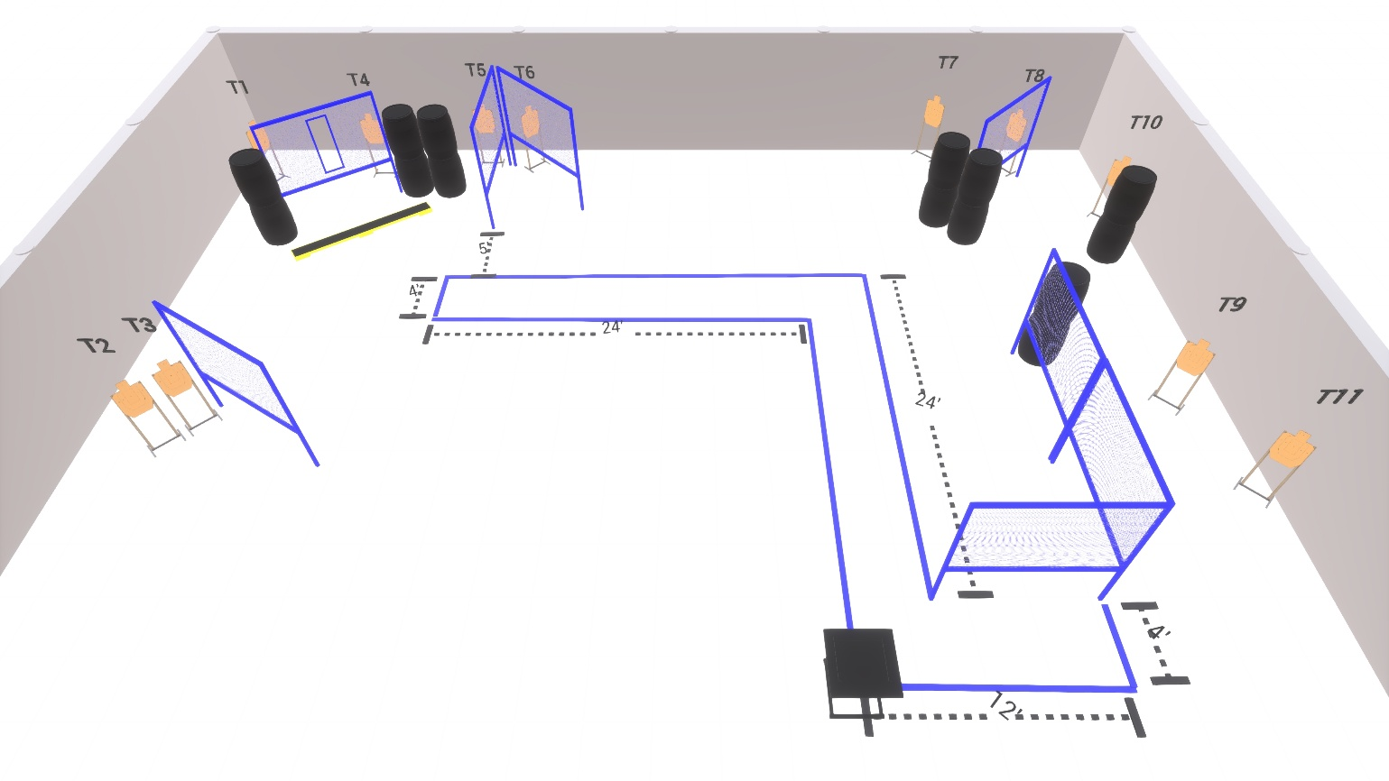

Written Stage Briefing:

Stage 2 – "Your move creep" - is a 33 round, 165 point, Comstock Course. There are 11 cardboard targets. The best 3 hits per target will be scored.

Starting with Both feet on XXs facing up range. Gun is unloaded and placed unpropped on barrel with muzzle point at the rear berm.

Facing uprange (start position only) Face and feet pointing directly (180 degrees) away from the backstop with shoulders and hips square to the backstop. A natural, "toes out" stance is acceptable and meets the standard of feet pointing directly away from the backstop, as long as both feet do not point in the same direction, and the rest of the position requirements are satisfied.

On the audible start signal, engage targets from within the shooting area.

USPSA / NROI Range Commands:
- Make Ready
- Are you ready?
- Standby
- If finished, unload and show clear
- If clear, hammer down and holster (Handgun)
If clear, hammer down and flag (PCC)
If clear, cylinder closed and holster (Revolver)
- Range is clear

Setup Notes:
10 Single Wall Stands
3 Double Wall Stands
7 Full Walls
1 Port Wall
11 Target stands / 22 target sticks
14+ Barrels



